**Experiment 4**

List out the required processes to be coded along with the required flow charts.

1. **Login**

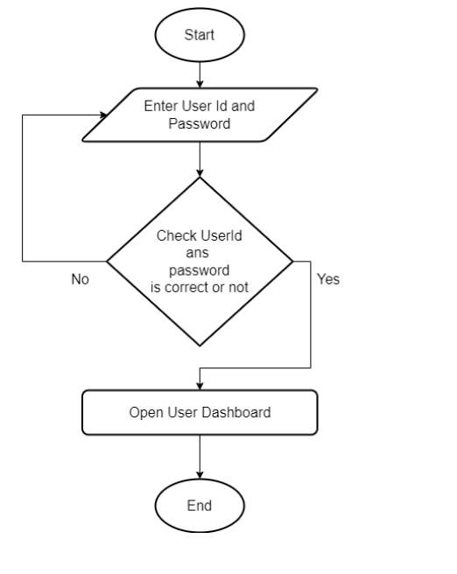

1. **Registration**

